**KUBERNETES EXERCISE**

**Problem** : as we learn about building helm chart and templates. We also learn about using values.yml file to update our resource using set parameters.

Below mentioned is the Github link which contains manifests https://github.com/gopal1409/ibmmanifestsep.git

1. To deploy my sql database this are manifest

a. pv.yaml

b. pvc.yml

c. secret.yaml

d. configmap.yml

e. mysql.yml

f. mysqlsvc.yml

**Solution**

g. Create an helm chart for mysql deployment

h. we are frequently updating the mysql image version using values.yml do the same

**🡪** Files are inside mysql folder

**-** Chart.yaml

apiVersion: v2

name: mysql

description: A Helm chart for Kubernetes

type: application

version: 0.1.0

appVersion: "1.0.0"

**-** values.yaml

image: mysql:5.6

**🡪** Other files are inside template folder inside mysql.

**-** Console outputs

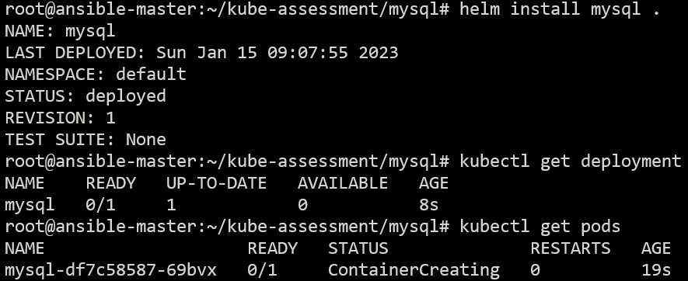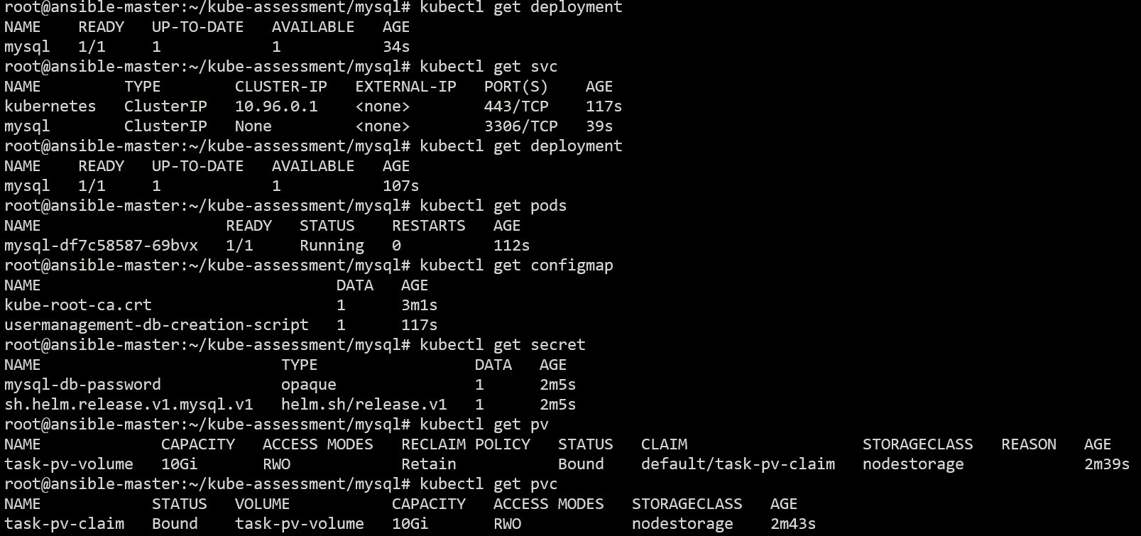

**Second Problem**

There are another two manifest file for front end.

1. Frontend.yaml

2. Fronendservice.yaml

**Solution**

1. Create another helm chart for frontend deployment

2. we are frequently updating the frontend service values.yml do the same. Try with load balancer nodeport and cluster ip

**🡪** Files are inside frontend folder

**-** Chart.yaml

apiVersion: v2

name: frontend

description: A Helm chart for Kubernetes

type: application

version: 0.1.0

appVersion: "1.0.0"

**-** values.yaml

service: LoadBalancer

**🡪** Other files are inside template folder inside mysql.

**-** Console Output

